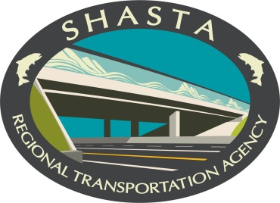
1255 East Street, Suite 202 • Redding, CA 96001 • (530)262-6190 • FAX (530)262-6189 E-Mail srta@srta.ca.gov • HOME PAGE www.srta.ca.gov
Daniel S. Little, Executive Director

Shasta Regional Transportation Agency

Travel Model Data Request Form

Firm/Organization:

Requested by and Date:

Address: Street:
City/State/Zip:
Phone/Fax:
E-mail:

Model to be used:
Shasta Model 1110 Version

Project/Application:

Purpose/Use of requested data:

I understand and agree to the following terms related to the use of the requested data:

Travel model files prepared by SRTA in cooperation with the Shasta Model Users Group (SMUG), including the associated input and prescribed output files, were developed for use by SMUG members exclusively. SRTA assumes no responsibility for the usage of the files, their state, or suitability for use, outside the agency. The files are provided "as is" and in no event shall the SRTA, County of Shasta and the regional partners be held liable for any damages arising from their use. The accuracy, validity, or reliability of the files is not guaranteed in any way. SRTA, County of Shasta and the regional partners disclaim all warranties, express or implied, including but not limited to liability for quality and fitness for a particular purpose arising out of the use of or inability to use the files. SMUG welcomes verifiable modifications necessary to enhance the integrity of the files.

The requested data is released by SRTA with the condition that it shall only be used for the specific project and purposes as stated in this form. Any subsequent projects by any local jurisdiction, consultant or other entity must submit a new data request form to SRTA.

We remind all consultants and jurisdictions, working on studies involving the use of the model, that all results of modeling work and related analyses should be submitted to your lead agency for review and concurrence before release of the results to any other parties. Our standards of review must include the option to re-run any of the consultant’s models to verify proper use of the travel model assumptions. Consultants shall provide the lead agency, by request of the SRTA, with a CD/DVD of all modeling work (whether or not it is a contract deliverable) the same way the model was made available to their organization representative. Specifically the lead agency will need to obtain copies of the final model streams for their records, including but not limited to, all input files, executables, intermediate files, and output files. Users shall provide, by request of the SRTA, on CD/DVD, including the identification of all files edited by hand (including step-by-step documentation) by the consultants accompanied by a description of how and why the files were modified, as well as any and all supporting files used to make such modification to the model, so that we are able to reproduce and replicate the results using only the information on these disks. It is in the consultant’s best interest to remain in close coordination with the lead agency.

SRTA in cooperation with SMUG will communicate to whomever signs this form any model updates going forward. It is expected that SMUG will meet bi-annually, or as needed if a material discrepancy is communicated to SMUG that requires more immediate action, to discuss the need for a new release and if warranted all model requestors will be automatically sent the update. The normal update process is every five years for the SRTA.

By signing this document I acknowledge that I have read SRTA’s Travel Demand Model Policies and Procedures document.

Signed Date:

Mail to: Sean Tiedgen - Associate Transportation Planner/SMUG coordinator
Shasta Regional Transportation Agency
1255 East Street, Suite 202
Redding, CA 96001
Phone: (530) 262-6190
Email: stiedgen@srta.ca.gov

