Zero-Emission Bus Rollout Plan Guidance for Transit Agencies
Prepared for the ZEB Rollout Plan Assistance Session at the
2022 CalACT Spring Conference and Expo

April 19, 2022

The Innovative Clean Transit (ICT) regulation became effective on October 1, 2019 and requires all California public transit agencies to gradually transition their bus fleets to zero-emission technologies. The ICT regulation applies to all transit agencies that own, operate, or lease buses with a gross vehicle weight rating (GVWR) greater than 14,000 pounds. It covers standard, articulated, over-the-road, double decker, and cutaway buses. The ICT regulation requires a percentage of new bus purchases to be zero-emission buses (ZEBs). The ZEB purchase requirement increases gradually over time. The ZEB purchase requirements begin in 2023 and 2026 for large and small transit agencies, respectively. Starting 2029, 100 percent of all transit agencies’ new bus purchases must be ZEBs, with a goal of complete transition to ZEBs (all buses in each transit agency’s fleet to be ZEBs) by 2040.

This document is created to facilitate the Zero Emission Bus Rollout Plan Assistance Session at the 2022 CalACT Spring Conference and Expo. This guidance document does not replace the adopted regulatory text, which takes precedence in all instances. The purpose of this document is to provide guidance on the content of the Rollout Plan, but transit agencies are not required to follow the exact format of this guidance document.

Successful transition of transit bus fleets to zero-emission technologies requires early planning which includes but is not limited to, route simulations, charging or hydrogen fueling site assessment, and identification and addressing of potential resource gaps, among the many preparatory steps. Transit agencies that have begun the transition to zero-emission technologies stress that early communication and engagement with ZEB manufacturers, technology providers, infrastructure providers, fuel providers, and other related parties are key to a successful and well-coordinated transition.

The ICT regulation requires each transit agency to submit a complete Zero-Emission Bus Rollout Plan (Rollout Plan) before ZEB purchase requirements take effect. The Rollout Plan is meant to be a living document and should guide the deployment of
zero-emission bus fleets and help transit agencies work through many of the potential challenges and explore solutions. Transit agencies should provide estimated timelines based on best available information for their bus purchases, infrastructure upgrades, workforce training, or any other timelines in a Rollout Plan. After the submission of the Rollout Plan, a transit agency may update the Rollout Plan as needed. It is recommended that major updates be resubmitted to CARB.

Transit agencies’ Rollout Plans will provide information on the strategies each transit agency has determined best fit their own unique situations. The components of a Rollout Plan will provide the State with crucial information, such as the probable number of buses to be deployed by each transit agency, which will inform future policy and funding decisions, and other ways State agencies can support transit agencies through this transition. The Rollout Plans will also help energy and fuel providers learn about transit agencies’ infrastructure needs during different stages of transition and help inform decisions regarding what support would best help transit agencies as they develop and expand the needed charging infrastructure. Information provided in the Rollout Plans is also critical to address barriers in implementation.

Each Rollout Plan must include all required components to be considered complete and must be approved by the transit agency’s governing body through the adoption of a resolution, prior to submitting it to CARB. Large transit agencies must submit their approved Rollout Plans by July 1, 2020, and small transit agencies must submit Rollout Plans by July 1, 2023 (13 CCR § 2023.1(d)(2)). The ICT regulation allows two or more transit agencies to pool their resources and form a Joint Zero-Emission Bus Group (Joint Group) to collectively comply with the ZEB purchase requirements. Members of an approved Joint Group may submit one Rollout Plan that is approved by each participating transit agency’s governing board, in lieu of submitting individual Rollout Plans.

The document summarizes the information required in a Rollout Plan to meet the requirements of the ICT regulation. In addition to required information (in black), this document identifies supplementary details (in grey) that could help transit agencies create a more thorough plan to meet their future needs. These supplementary details will also improve the State’s understanding of transit agencies’ operations and plans so the State can provide more targeted support. Response to these supplementary details is highly recommended, but not required. The fields required by the regulation are identified by citing the specific code sections or including the word “required,” whereas the supplementary fields are identified by the word “optional.” In addition, tips and recommendations are also provided for Rollout Plan considerations. These recommendations are in text boxes in blue. Examples and screenshots from some large transit agencies’ Rollout Plans are also shown here for demonstration purpose.

This document contains ten (10) sections:
Section A: Transit Agency Information
Section B: Rollout Plan General Information
Section C: Technology Portfolio
Section D: Current Bus Fleet Composition and Future Bus Purchases
Section E: Facilities and Infrastructure Modifications
Section F: Providing Service in Disadvantaged Communities
Section G: Workforce Training
Section H: Potential Funding Sources
Section I: Start-up and Scale-up Challenges
Section J: Example of a Resolution Language

The ICT regulation and other regulatory documents are available at the Innovative Clean Transit website (https://ww2.arb.ca.gov/our-work/programs/innovative-clean-transit). Zero-Emission Bus Rollout Plans from large transit agencies are posted at the ICT-Rollout Plan webpage (https://ww2.arb.ca.gov/our-work/programs/innovative-clean-transit/ict-rollout-plans) for reference purposes. For comments and questions, please contact Ms. Yachun Chow, managers of Zero Emission Truck and Bus section at yachun.chow@arb.ca.gov or, Ms. Shirin Barfjani, Air Pollution Specialist, at shirin.barfjani@arb.ca.gov.

Section A: Transit Agency Information
Please provide the following information regarding your transit agencies:
- Transit agency’s name (required)
- Mailing address (number, street, city, county, Zip Code) (optional)
- Name of transit agency’s air district(s) (optional)
- Name of transit agency’s air basin(s) (optional)
- Total number of buses in Annual Maximum Service (optional)
- Population of the urbanized area a transit agency is serving as last published by the Census Bureau before December 31, 2017. (optional)
- Contact information of the general manager, chief operating officer, or equivalent (optional)
  - Contact name (last name, first name, MI)
  - Title
  - Phone number
  - Email address
- Is your transit agency part of a Joint Group (13 CCR § 2023.1(d)(3))? (Yes/No) (required)
  - If yes, please provide the following information:
    - Is your transit agency submitting a separate Rollout Plan specific to your agency, or will one Rollout Plan be submitted for all participating members of the Joint Group (13 CCR § 2023.1(d)(3))? (required)
    - Please provide a complete list of the transit agencies that are members of the Joint Group. (optional)
    - Please provide contact information for the general manager, chief operating officer, or equivalent staff member of each participating transit agency member. (full name, title, affiliation, phone number, and email address) (optional)
Example 1: Riverside Transit Agency Information
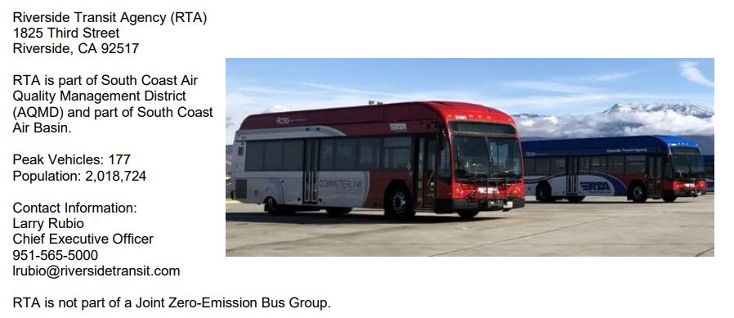

Section B: Rollout Plan General Information
- Does your transit agency’s Rollout Plan have a goal of full transition to zero-emission technologies by 2040 that avoids early retirement of conventional transit buses (13 CCR § 2023.1(d)(1)(A))? (Yes/No) (required)
- The ICT regulation requires 100% ZEB purchase in 2029. Conventional transit buses that are purchased in 2028 could be delivered in or after 2029. Please explain how your transit agency plans to avoid potential early retirement of conventional buses in order to meet the 2040 goal. (optional)
- When did your transit agency’s board or governing body approve the Rollout Plan?
  - Rollout Plan’s approval date (MM/DD/YYYY) (optional)
  - Resolution number (optional)
  - Is a copy of the board approved resolution attached to the Rollout Plan submitted to CARB (13 CCR § 2023.1(d)(2))?
(Yes/No) (required)
- Please provide contact information for CARB to follow up on details of the Rollout Plan, if needed. (optional)
  - Contact name (first and last name)
  - Title
  - Phone number
  - Email
- Who has created the Rollout Plan? (My transit agency / A consultant) (optional)
  - If it was created by a consultant, please identify the consulting company’s name.
- What was the cost for the creation of the Rollout Plan? (optional)
- How many person-hours did it take to create the Rollout Plan? (optional)
Note: The ICT regulation does not require any accelerated ZEB purchases or early retirements of conventional buses to achieve the 2040 goal. Transit agencies must commit to the 2040 goal with their best effort, but may provide a brief explanation if they cannot meet the 2040 goal without having accelerated ZEB purchase or early retirement of the conventional buses.

Example 2: This example shows the language Alameda-Contra Costa Transit District (AC Transit) and San Diego Metropolitan Transit System (MTS) provided in their Rollout Plans for meeting the 2040 goal.
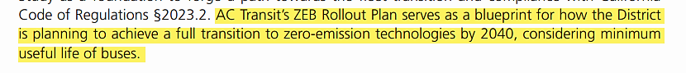
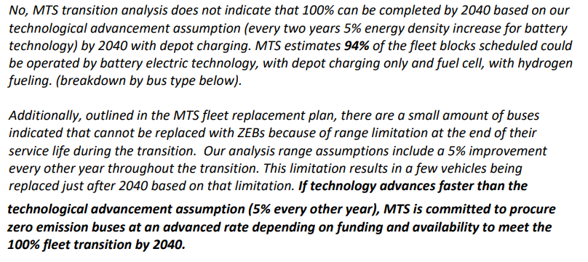

Section C: Technology Portfolio
- What type(s) of zero-emission bus technologies (e.g., battery electric and fuel cell electric buses) does your transit agency plan to deploy through 2040? (13 CCR § 2023.1(d)(1)(B)) (required)
Note: Daily range or energy consumption is one of the key factors to select the suitable ZEB technology. Transit agencies are encouraged to perform route simulation to understand the energy consumption.
Zero-emission bus fuel efficiency could be used as a surrogate for such estimate. Bus range is impacted by many factors, including terrain, ambient temperature, passenger load, driving cycles, operation hours, etc. In addition to bus range, transit agencies should also consider other factors, such as hours of operation (to determine whether slow charging is feasible), infrastructure footprint or setback requirement, electrical capacity, fuel costs, etc.

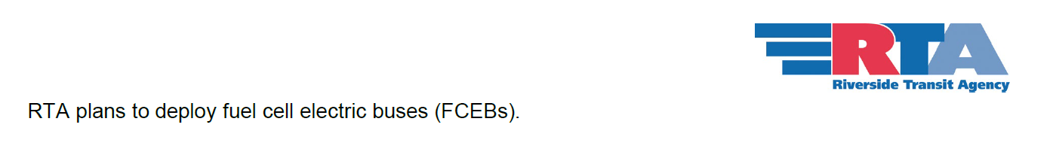
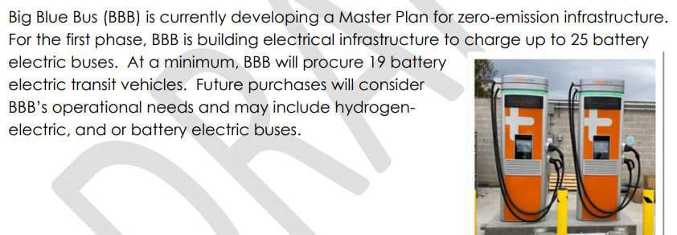
Example 3: This example shows Santa Monica’s Big Blue Bus (BBB) and Riverside Transit Agency’s (RTA) technology portfolios.

Section D: Current Bus Fleet Composition and Future Bus Purchases
- Please complete Table 1 with information on each individual bus in your current bus fleet. Please identify the fuel type of each individual conventional bus as diesel, compressed natural gas (CNG), liquefied natural gas (LNG), diesel hybrid (dHEB), gasoline hybrid (gHEB), propane, or gasoline. For zero-emission technologies, identify the fuel type as hydrogen or electricity and indicate which charging technology (depot, wireless, and/or on-route) will be used. Bus types include standard, articulated, over-the-road, double decker, and cutaway buses. For ease of use, you can group the bus information based on a parameter that makes the most sense for your transit agency. For example, California-Heritage Transit has 12 standard diesel buses that are 2017 bus model year with 2016 model year engines. In addition, this transit agency has 3 articulated diesel buses that are 2011 bus model year with 2010 model year engine. Table 1 can be used to prepare the replacement schedule, which facilitates the construction of future bus purchases (Table 2). (optional)
Table 1: Individual Bus Information of Current Bus Fleet (Optional)

Number of Buses | Engine Model Year | Bus Model Year | Fuel Type | Bus Type
12 | 2016 | 2017 | Diesel | Standard
3 | 2010 | 2011 | Diesel | Articulated

- Please complete Table 2 regarding expected future bus purchases, including the total number of buses expected to be purchased or leased in the year of purchase. Identify the number and percentage of zero-emission buses of the total number of bus purchases each year, as well as bus types and fuel types. Identify the same type of information for purchases of conventional buses. Bus types include standard, articulated, over-the-road, double decker, and cutaway buses. For
zero-emission technologies, please identify the fuel type as hydrogen or electricity and indicate the charging technology (depot, wireless, and/or on-route). For conventional technologies, identify the fuel type as diesel, compressed natural gas (CNG), liquefied natural gas (LNG), diesel hybrid (dHEB), gasoline hybrid (gHEB), propane, or gasoline.
(13 CCR § 2023.1(d)(1)(D)) (required)

Table 2: Future Bus Purchases (Required)
Timeline  (Year) | Total Number of Buses to Purchase | Number  of ZEB Purchases | Percentage of Annual ZEB Purchases | ZEB  Bus Type(s) | ZEB  Fuel  Type(s) | Number of Conv. Bus Purchases | Percentage of Annual Conv.  Bus Purchases | Type(s) of Conv. Buses | Fuel Type(s) of Conv. Buses
Note: It is recommended to start with the current bus fleet information (Table 1) to establish the bus replacement timeline, then back calculate the purchase year. The bus replacement timeline may be prepared either based on transit agencies historical data (i.e., replacing a standard 40-ft bus after 14 years of service), or based on the Federal Transit Administration minimum useful life requirement (i.e., minimum of 12 years of service for a standard 40-ft bus). Once the replacement timeline is clear, the purchase year can be estimated by back calculating the time between the issuance of a Notice to Proceed to the bus delivery. It could take 18-24 months between issuing a Notice to Proceed and the bus delivery. The future bus purchase schedule must be aligned with the ICT ZEB purchase requirement. Examples 4 and 5 demonstrate how the bus purchase schedule could be prepared.

Example 4: Transit Agency A is a small transit agency with a total of 28 buses, out of which 19 are standard buses (2x 2013 model year (MY), 9x 2016 MY, 8x 2017 MY) and 9 are cutaway buses (6x2018 MY and 3x2019 MY). This transit agency replaces its standard buses every 12 years and cutaway buses every 7 years. This transit agency issues the Notice to Proceed 2 years before the bus delivery.
Year | Total Bus Purchase | ZEB Purchase Requirements | ZEB # | ZEB Type | ZEB Fuel Type | Conventional Bus # | Conv. Bus Type | Conv. Fuel Type
2023 | 8 | 0% | 2* | Standard | Electricity | 6 | Cutaway | Diesel
2024 | 3 | 0% | 0 | - | - | 3 | Cutaway | Diesel
2025 | 0 | 0% | 0 | - | - | 0 | - | -
2026 | 9 | 25% | 0** | - | - | 9** | Standard | Diesel
2027 | 6*** | 25% | 1 | - | - | 5 | Standard | Diesel
2028 | 2*** | 25% | 0 | - | - | 2 | Standard | Diesel
2029 | 0 | 100% | 0 | - | - | 0 | - | -
2030 | 6 | 100% | 6 | Cutaway | Hydrogen | 0 | - | -
2031 | 3 | 100% | 3 | Cutaway | Hydrogen | 0 | - | -
2032 | 0 | 100% | 0 | - | - | 0 | - | -
2033 | 0 | 100% | 0 | - | - | 0 | - | -
2034 | 0 | 100% | 0 | - | - | 0 | - | -
2035 | 2 | 100% | 2 | Standard | Electricity/ Hydrogen | 0 | - | -
2036 | 0 | 100% | 0 | - | - | 0 | - | -
2037 | 6 | 100% | 6 | Cutaway | Hydrogen | 0 | - | -
2038 | 12 | 100% | 9  3 | Standard  Cutaway | Electr/Hydrogen  Hydrogen | 0 | - | -
2039 | 6 | 100% | 6 | Standard | Electricity/ Hydrogen | 0 | - | -
2040 | 2 | 100% | 2 | Standard | Electricity/ Hydrogen | 0 | - | -

In this example, Transit Agency A purchases two battery electric buses (BEB) in 2023 which is considered above and beyond the ZEB purchase requirements. These two BEBs can be counted toward meeting its compliance obligation starting in 2026 if they are still in service. In 2026 the transit agency will purchase 9 buses, with two of them being ZEBs (9x25%=2.25 ZEBs. 2.25 is rounded down to 2 ZEBs) to comply with the ICT regulation. Because this transit agency has two existing ZEBs from the previous purchase in 2023, it does not need to purchase any new ZEBs and can purchase nine conventional buses. It is important to note that the compliance calculation is based on the purchase, not the vehicle delivery.
Transit agency A wants to purchase 8 buses in 2027. This transit agency’s charging infrastructure can only accommodate one additional BEB and does not plan on adding more. If this transit agency purchases all 8 buses at once, two of these buses must be ZEBs (8x25%=2 ZEBs) which will exceed its charger number. Therefore, Transit Agency A splits its bus purchases over two consequential years. In 2026 it issues the notice to proceed to purchase only 6 buses and as a result, it only needs to purchase one ZEB (6x25%=1.5 ZEBs. 1.5 is rounded down to 1 ZEB). In 2027 it purchases the rest of the 2 buses and does not need to purchase any ZEBs (2x0.25=0.5 ZEB. 0.5 is rounded down to 0 ZEBs). Because of this purchase split, transit agency A can comply with the ICT regulation while purchasing the buses needed for its service.
Note: If the calculated required minimum number of zero-emission buses as does not result in a whole number, the number must be rounded to the nearest integer. i.e., 7x25%=1.75, which must be rounded up to 2 ZEBs or 5x25%=1.25, which must be rounded down to 1 ZEB. If the number has 0.5 as a decimal, it should be rounded down. i.e., 2x025%=0.5, which will be rounded down to 0.

The required minimum number of ZEBs can be met with any combination of the following:
(1) bonus credits; (2) zero-emission mobility credits; (3) existing ZEBs in the fleet; and (4) new ZEB purchase. Bonus and zero-emission mobility credits must be used before the existing ZEBs are used for compliance. In addition, bonus and zero-emission mobility credits and existing ZEBs may only be used once and will be used first before new ZEB purchases are counted towards compliance. Existing ZEBs include any ZEBs from previous purchases, any leased ZEBs, and any ZEBs converted from a conventional bus. More information and examples are available at the ICT Implementation Guidance Document.
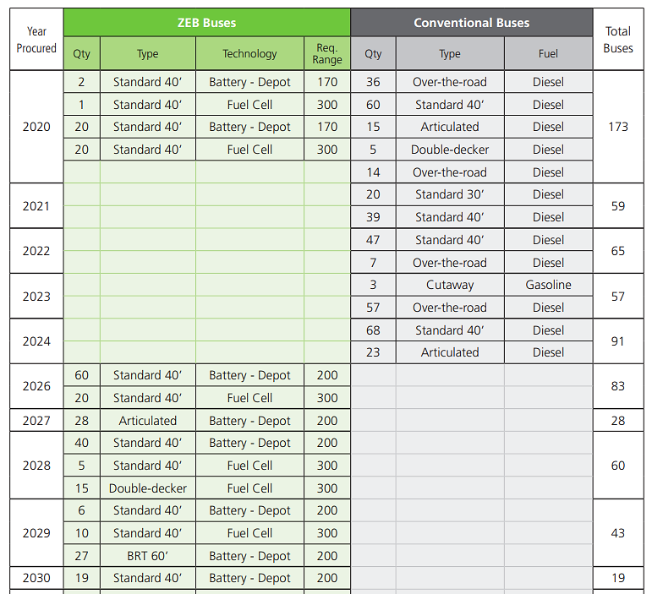
Example 5: This example shows the Alameda-Contra Costa Transit District’s (AC Transit) future bus purchase schedule (the actual plan goes to 2040). This bus purchase schedule reflects the required bus range and shows how AC Transit plans to purchase the ZEB technologies that suit its needs. Battery electric buses with a higher range are phased in later.
- Is your transit agency considering converting some of the conventional buses in service to zero-emission buses
(13 CCR § 2023.1(d)(1)(E))? (Yes/No) (required)
  - If yes, please complete Table 3 with your transit agency’s schedule to convert the conventional buses to zero-emission technologies (13 CCR § 2023.1(d)(1)(E)). (required)
Table 3: Schedule of Converting Conventional Buses to Zero-Emission Buses (required)
Timeline  (Year) | Number of Buses | Bus Type(s) | Removed Propulsion System | New Propulsion System

Example 6: Two examples about bus conversion are provided here. The top screenshot shows the Los Angeles County Metropolitan Transportation Authority’s explanation on why the conversion option is considered in their Plan and the provided conversion schedule. The bottom screenshot shows the Omnitrans’ language indicating the conversion option is not considered at the time of planning.
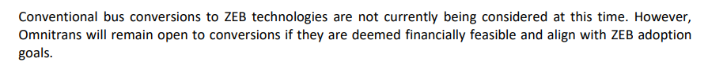
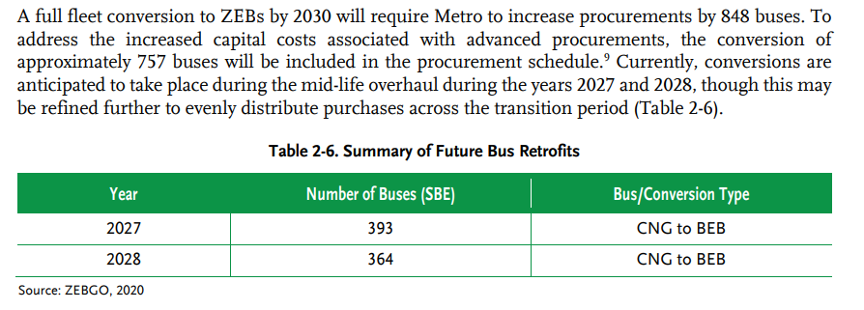
Section E: Facilities and Infrastructure Modifications
- Please complete Table 4 with names, locations, and main functions of transit agency divisions or facilities that would be involved in deploying and maintaining zero-emission buses. Please limit the facilities to bus yards and facilities with maintenance, fueling, and charging functions, and exclude other operational functions like training centers, information and trip planning offices, and administrative buildings. Please identify which facility(ies) require construction, infrastructure modifications, or upgrades to support your transit agency’s long-term transition to zero-emission technologies and the estimated timeline for such an upgrade. Please also specify the type(s) of infrastructure planned in each division or facility and provide their service capacities (e.g., on-route high-power charging system) to deploy 20 BEB in 2025 (13 CCR § 2023.1(d)(1)(C)). (required)
Table 4: Facilities Information and Construction Timeline (Required)

Division/ Facility Name | Address | Main Function(s) | Type(s) of  Infrastructure | Service  Capacity (bus number) | Needs Upgrade?  (Yes/No) | Estimated  Construction Timeline

- For information provided in Table 4, please explain the types of necessary upgrades or infrastructure modifications each facility or division need to support your transit agency’s long-term transition to ZEB. Please also provide the specification of each infrastructure in the related facility or division before and after the upgrades or modifications. For example, Division Blue Sky has a parking capacity of 150 buses in 2020. In 2025, after parking rearrangement and installation of 30 depot fast chargers with the power of 150 kW, this facility is expected to accommodate 120 buses; or Division Enchanting Waterfalls will deploy 20 fuel cell electric buses (FCEBs) in 2025 with trucked-in liquid hydrogen for 1,500 kg of storage capacity and will expand to 120 FCEBs in 2035 with trucked-in liquid hydrogen for 9,000 kg of storage capacity; or Division Evergreen will deploy 20 BEBs in 2025 using an on-route high-power charging system (500 kW) with 10 chargers and will expand to 200 BEBs in 2040 using the same charging method with 15 MW of on-site power. (Optional)

- Do you expect to make any modifications to your bus parking arrangements? Explain the modifications and why they are needed. (Optional)
- Do you expect to need additional parking spaces for completing the transition to zero-emission technologies? Explain why.
(Optional)
- In Table 5, please identify the propulsion system (e.g., diesel, CNG, battery electric, fuel cell) of all buses that will be dispatched from the facilities identified in Table 4. Are any of these facilities located in NOx-exempt areas? (optional)
Table 5: NOx-Exempt Area and Electric Utilities' Territories (Optional)

Division’s Name  (Same as in Table 4) | Type(s) of Bus  Propulsion System | Located in NOx-Exempt Area? (Yes/No)

- Please identify the electric utilities in your transit agency’s service area. (Optional)
Note: It is highly recommended to start planning the infrastructure modification before initiating any zero-emission bus procurement! Engage your utility and energy provider early in planning and engineering to:
  - Evaluate existing infrastructure
  - Understand EV rate structure
  - Make ready infrastructure
  - Plan charging times
  - Decide on how to scale up

There should be synchronization between bus procurement, bus delivery, and infrastructure upgrade to assure the deployment once buses are delivered. Several items can impact infrastructure modification timeline of battery electric bus infrastructure:
  - Utility engagement
  - Evaluation of sites, service, and infrastructure needs
  - Planning
  - Requests for proposals and bids
  - Electrical upgrades and construction of supporting structures
  - Temporary relocation
  - Permitting
  - Design the layout and operations of the updated yard
  - More

Following items are important to consider for Hydrogen infrastructure and may impact the timeline:
  - Issuance of an RFP for consulting services, if needed
  - Determination of manufacturing the hydrogen on site (e.g., steam methane reformation, Electrolyzer, or gasification) or truck-in liquid or gaseous Hydrogen
  - Decision to own or lease the Hydrogen tank and fueling station
  - Planning
  - Permitting
  - Issuance of an RFP for Design Build of hydrogen Infrastructure for truck-in liquid Hydrogen
  - Issuance of an RFP for upgrade of maintenance building relative to hydrogen leak detection and ventilation
  - Does the agency want three separate contracts for Design Build, O&M, and Fuel provision?
  - Demonstration of FCEBs (Currently, there are only two bus manufactures: New Flyer and ElDorado)
  - Determination of required bus specifications based on bus performance relative to the routes
  - Design the layout and operations of the updated yard, if needed
  - Synchronization of FCEB delivery with completion of hydrogen infrastructure and fueling station. FCEBs will be used to commission the fueling station.
  - More
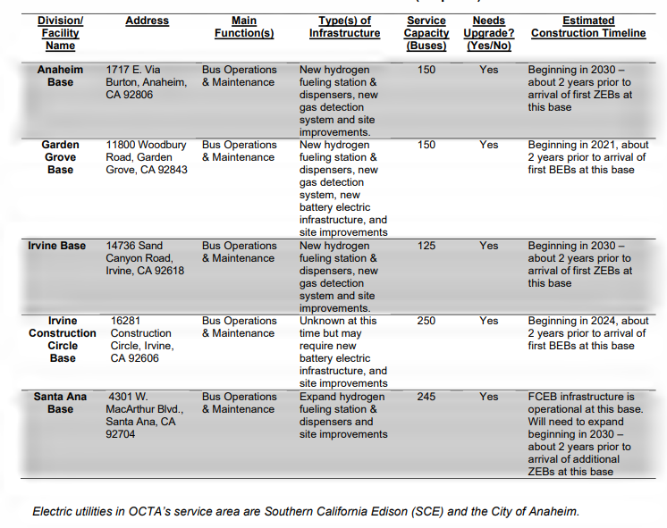
Example 7: This example shows Orange County Transportation Authority’s infrastructure modifications timeline. The construction timeline is aligned with the bus purchase and delivery.

Section F: Providing Service in Disadvantaged Communities
- Does your transit agency serve one or more disadvantaged communities, as listed in the latest version of CalEnviroScreen? Yes/ No (required)
  - If yes, please describe how your transit agency is planning to deploy zero-emission buses in disadvantaged communities (13 CCR § 2023.1(d)(1)(F)). (required)
  - Please complete Table 6 with the estimated number of zero-emission buses your transit agency is planning to deploy in disadvantaged communities and the estimated timeline.
Table 6: Service in Disadvantaged Communities (Optional)

Timeline (Year) | Number of ZEBs | Location of Disadvantaged Community
Note: Disadvantaged Communities (DACs) is defined as the top 25% scoring areas from CalEnviroScreen (https://oehha.ca.gov/calenviroscreen) along with other areas with high amounts of pollution and low populations. Transit agencies should utilize the latest version of CalEnvioScreen to identify DACs based on the census tracts their bus routes pass through. The ICT regulation does not require transit agencies to prioritize ZEB deployment in DACs.
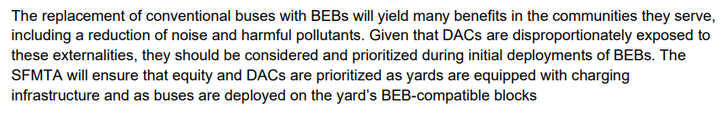
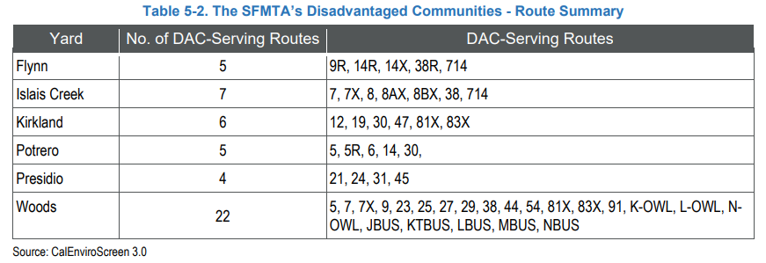
Example 8: This example shows how San Francisco Municipal Transportation Agency identifies DACs and plans to periodize ZEB deployment in these areas.
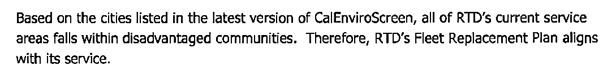
Example 9: Below are examples of transit agencies that either none of their routes passes the DACs, like North County Transit District (left) or all their service area are within DACs, like San Joaquin Regional Transit District (right).

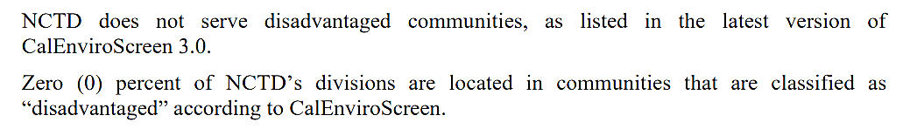
Section G: Workforce Training
- Please describe your transit agency’s plan and schedule for the training of bus operators and maintenance and repair staff on zero-emission bus technologies (13 CCR § 2023.1(d)(1)(G)). (required)
- Please complete Table 7. (optional)
Table 7: Workforce Training Schedule (Optional)

Timeline  (Year) | Training Program/ Class | Purpose of Training | Name of Provider | Number of Trainees | Trainees’ Positions | Training Hours | Training Frequency | Estimated Costs Per Class

Note: Examples of available training Programs

- SunLine West Coast Center of Excellence in Zero-Emission Technology (CoEZET)
- AC Transit ZEB University
- Zero Emission Bus Resource Alliance (ZEBRA)
- Southern California Regional Transit Training Consortium (SCRTTC)
- FTA Transit workforce center
- Electric Vehicle Infrastructure Training Program (EVITP)
- H2Tools funded by US-DOE
- Manufacturers provided training (MCI Academy, New Flyer Vehicle Innovation Center (VIC), New Flyer Anniston Workforce Development Program (AWDP))
Types of Training A Transit Agency Need
- Agency overall system orientation
- First responders training
- Bus operators training
- Facilities maintenance staff training
- Mechanics trainings
- Service workers training
- Towing service providers training

Example 10: San Joaquin Regional Transit District uses bus and charger manufacturers' training (top screenshot). These trainings are aligned with the ZEB purchase and infrastructure upgrades. Other transit agencies, including Orange County Transportation Authority, provide recurring and episodical trainings upon new vehicle delivery (bottom screenshot).
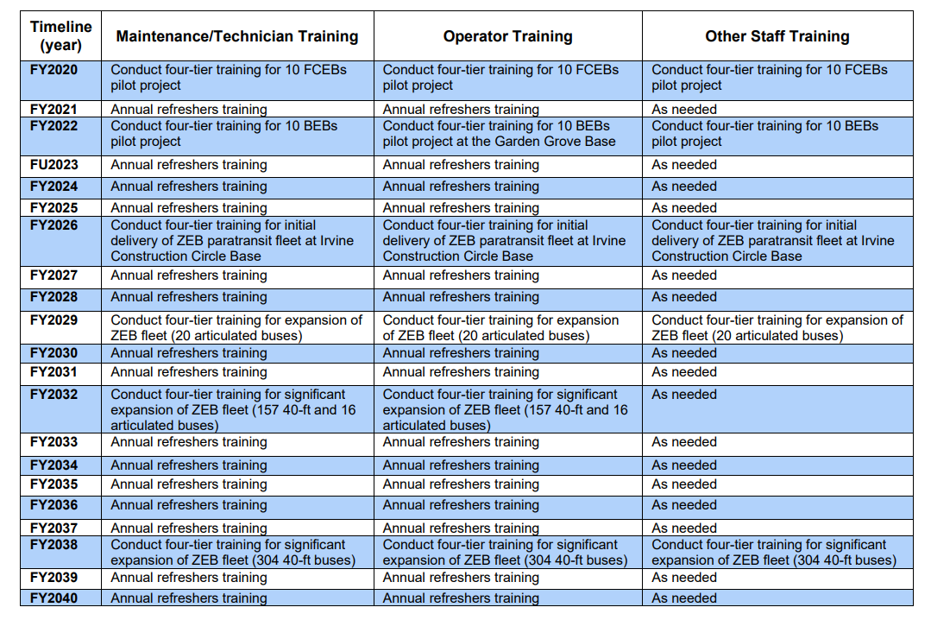

Section H: Potential Funding Sources
- Please identify all potential funding sources your transit agency expects to use to acquire zero-emission technologies (both vehicles and infrastructure) (13 CCR § 2023.1(d)(1)(H)). (required)
- In Table 8, please describe how the identified potential funding sources could support your transit agency to execute the Rollout Plan as currently designed by describing how each fund is planned to be used over time (e.g., to purchase a zero-emission bus, maintain a zero-emission bus, upgrade the charging/fueling infrastructure, construct or upgrade a maintenance facility). Please also identify how many zero-emission buses and/or which type(s) of infrastructure might be purchased, installed, or maintained with each funding source. (optional)
Table 8: Potential Funding Sources (Optional)
Note: Both formula and discretion funds can be listed. It is the understanding that listing the discretion fund does not guarantee the receipt of the fund. Examples of some important funding sources are provided below:
Federal funding sources:
- FTA Low and No Emissions Program (Low-No)
- FTA Bus & Bus Facilities Program
- Urbanized Area Formula
- Better Utilizing Investments to Leverage Development (BUILD)
- Transportation Grants Program (formerly TIGER)
- Capital Investment Grants
- Rural Operators Program
Timeline  (Year) | Name of Funding Source | How Each Fund is Planned to be Used | Estimated Amount(s) of Each Funding Source ($) | Number of ZEBs to Purchase or Maintain, or Type(s) of Infrastructure to Install or Upgrade
Low Carbon Fuel Standard
LCFS is a regulation. It is designed to encourage the use of cleaner low-carbon transportation fuels in the transportation sector. Transit agencies, as electric charger and hydrogen station owners are first in line to register in the LCFS Reporting Tool and report the electricity and hydrogen usage to generate credits. Credits have monetary value and can be used to reduce the operational cost.

State Funding Sources:
- Hybrid and Zero-Emission Truck and Bus Voucher Incentive Project (HVIP)
- Volkswagen Mitigation Trust
- Carl Moyer Program
- Low Carbon Fuel Standard (LCFS) (it is a regulation)
- Low Carbon Transit Operations Program (LCTOP)
- Transit & Intercity Rail Capital Program (TRICP)
Regional Programs:
- Air quality management district programs
- Local Funds
- Sales tax revenue
- Gas tax revenue
- Toll revenue
Infrastructure funding sources
- Energy Infrastructure Incentives for Zero-Emission Commercial Vehicles (EnnergIIZE Commercial Vehicles)
- Medium- and Heavy-Duty Charging and Refueling Infrastructure Projects
- Clean Transportation Program (CTP)
- Utility Programs

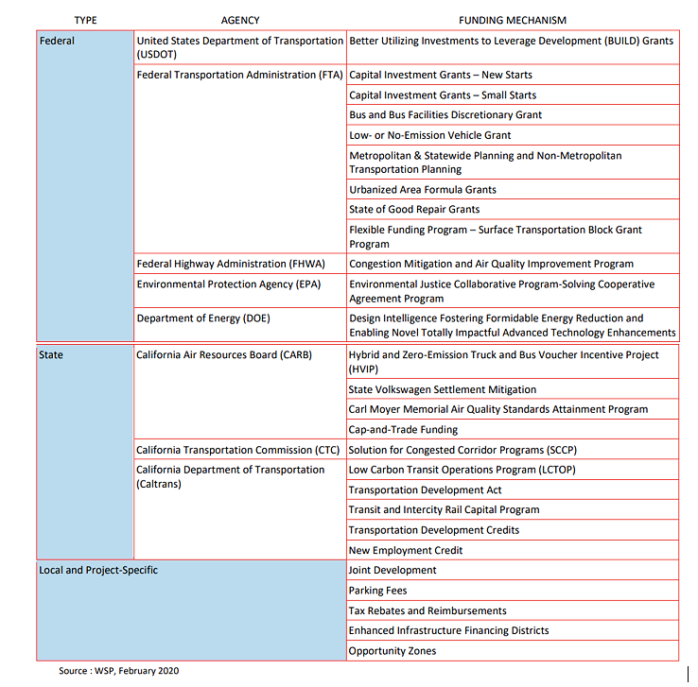
Example 11: Omnitrans’ ZEB funding opportunities

Section I: Start-up and Scale-up Challenges
- Please describe any major challenges your transit agency is currently facing in small scale zero-emission bus deployment. (Optional).
  - How might CARB assist you to overcome these challenges? Please share your recommendations. (Optional)
- Please describe any challenges your transit agency may face in scaling up zero-emission bus deployment. (Optional)
  - How might CARB assist you to overcome these challenges? Please share your recommendations. (Optional)
Identification of challenges is optional, but it is highly recommended as they allow CARB and other state agencies to learn about transit agencies’ needs during different stages of transition and help them to have informed decisions regarding what support would best help transit agencies. This information is critical to address barriers in implementation.

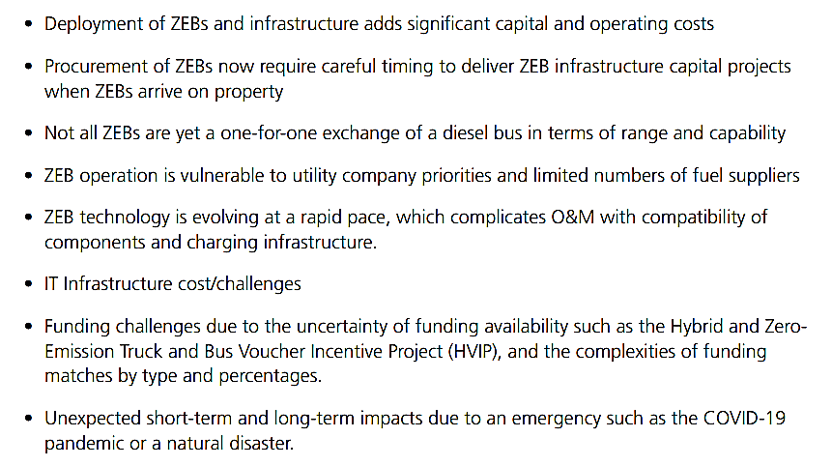
Example 12: List of identified challenges by Alameda-Contra Costa Transit District.

Section J: Example of a Resolution Language

RESOLUTION NO. XX-XX

RESOLUTION OF THE BOARD OF DIRECTORS OF THE
(transit’s name)
APPROVING THE ZERO-EMISSION BUS ROLLOUT PLAN

WHEREAS, California Code of Regulations Title 13, Division 3, Chapter 1, Article 4.3, Part 2023.1(d) Zero Emissions Bus Rollout Plan Requirements requires that a transit agency Zero-Emission Bus Rollout Plan must be approved by its governing Board; and

WHEREAS, Zero-Emission Bus Rollout Plan sets forth the (transit’s name)’s plan which meets the following requirements:

- A goal of full transition to zero-emission buses by 2040 with careful planning that avoids early retirement of conventional internal combustion engine buses;
- Identification of the types of zero-emission bus technologies (transit’s name) is planning to deploy;
- A schedule for zero-emission and conventional internal combustion engine bus purchases and lease options;
- A schedule for conversion of conventional internal combustion engine buses to zero-emission technologies;
- A schedule for construction of facilities and infrastructure modifications or upgrades, including charging, fueling, and maintenance facilities, to deploy and maintain zero-emission buses;
- Explanation of how (transit’s name) plans to deploy zero-emission buses in Disadvantaged Communities;
- A training plan and schedule for zero-emission bus operators and maintenance and repair staff; and
- Identification of potential funding sources.

NOW, THEREFORE, BE IT RESOLVED that the Board of Directors of the (transit’s name) hereby approves the (transit’s name)’s Zero-Emission Bus Rollout Plan as set forth in full.

BE IT FURTHER RESOLVED that insofar as the provisions of any Ordinance, Resolution, document, or previous action of the Board and/or the Executive Director, prior to the date of this Resolution, are inconsistent with the provisions of this Resolution or any policy adopted by this Resolution, this Resolution and the Board Policies adopted herein shall control.


PASSED, APPROVED AND ADOPTED at the regular meeting of the Board of Directors of the (transit’s name) this (date).
Page 2 of 3

BOARD CHAIR Signature

CERTIFICATION

I, (Clerk of the Board’s name), duly appointed and qualified, Clerk of the Board of the (transit’s name), do hereby certify that the above is a true and correct copy of a resolution passed and approved by the Board of Directors of the (transit’s name) adopted at a legally convened meeting of the Board of Directors of the (transit’s name) held on the (date).

CLERK OF THE BOARD Signature

The ICT regulation defines a “Large Transit Agency” (13 CCR § 2023(b)(30)) as a transit agency that meets one of the following criteria: - It operates either in the South Coast or the San Joaquin Valley Air Basin and operates more than 65 buses in annual maximum service; or - It operates outside of these areas, but in an urbanized area with a population of at least 200,000 as last published by the Bureau of Census before December 31, 2017, and has at least 100 buses in annual maximum service.
The ICT regulation defines a “Small Transit Agency” (13 CCR § 2023(b)(49)) as all other transit agencies that do not meet the definition of the “Large Transit Agency”.
A Joint Group must meet at least one of the following eligibility criteria (13 CCR § 2023.2(a)): All members of a Joint group must be located within the same service area of a Metropolitan Planning Organization (MPO) or Regional Transportation Planning Organization; or be located within the same air basin, Air Quality Management District, Air Pollution Control District, or Air Resources District; or share infrastructure.
The ICT regulation defines “Annual Maximum Service” (13 CCR § 2023(b)(3)) as the number of buses in revenue service that are operated during the peak season of the year, on the week and day that maximum service is provided but excludes demand response buses. Annual maximum service excludes an atypical service day, on which a transit agency provides extra service to meet the demands for special events such as conventions, parades, or public celebrations, or operates significantly reduced service because of unusually bad weather (e.g., snowstorms) or major public disruptions (e.g., earthquakes or terrorism); or one-time special events.
The ICT regulation defines a Joint Zero-Emission Bus Group or Joint Group (13 CCR § 2023.2) as two or more transit agencies that choose to form a group to comply collectively with the zero-emission bus requirements of section 2023.1 of the ICT regulation.
https://ww2.arb.ca.gov/sites/default/files/2021-03/RTA_ZEB_ROP_ADA12212020.pdf
https://ww2.arb.ca.gov/sites/default/files/2020-09/AC%20Transit%20ZEB%20Rollout%20Plan_ADA06102020.pdf
https://ww2.arb.ca.gov/sites/default/files/2020-12/SDMTS%20ROP_ADA113020.pdf
https://ww2.arb.ca.gov/sites/default/files/2020-09/Santa%20Monica%20BBB_ROP_ADA08052020.pdf
https://ww2.arb.ca.gov/sites/default/files/2021-03/RTA_ZEB_ROP_ADA12212020.pdf
The ICT regulation defines a “bus purchase” (13 CCR § 2023(b)(7)) as occurring when a transit agency executes one of the following after it has identified, committed, and encumbered funds: - A written Notice to Proceed to a bus manufacturer to begin production of a bus either under a previously-entered purchase contract; or to execute a contract option; - If no Notice to Proceed is issued, a written purchase agreement between a transit agency and a bus manufacturer that specifies the date when the bus manufacturer is to proceed with the work to manufacture the bus; or - A signed written lease agreement between a transit agency and a bus manufacturer or sales representative for a new bus to be placed in revenue service for a contract term of five years or more.
https://ww2.arb.ca.gov/sites/default/files/2020-09/AC%20Transit%20ZEB%20Rollout%20Plan_ADA06102020.pdf
https://ww2.arb.ca.gov/sites/default/files/2021-09/LAMetroRolloutPlanADA.pdf
https://ww2.arb.ca.gov/sites/default/files/2020-09/Omnitrans_ROP_ADA08262020.pdf
The ICT regulation defines “NOx Exempt Areas” (13 CCR § 2023(b)(39)) as the following counties and air basins: Alpine, Amador, Butte, Calaveras, Colusa, Del Norte, Eastern Kern (the portion of Kern County within the Eastern Kern Air Pollution Control District), Glenn, Humboldt, Inyo, Lake, Lassen, Mariposa, Mendocino, Modoc, Mono, Monterey, Nevada, Northern Sonoma (as defined in title 17, California Code of Regulations, section 60100(e)), Plumas, San Benito, San Luis Obispo, Santa Barbara, Santa Cruz, Shasta, Sierra, Siskiyou, Northern Sutter (the portion of Sutter County that is north of the line that extends from the south east corner of Colusa County to the southwest corner of Yuba County), the portion of El Dorado County that is within the Lake Tahoe Air Basin (as defined in title 17, California Code of Regulations, section 60113), the portion of Placer County that is East of Highway 89 or within the Lake Tahoe Air Basin, Trinity, Tehama, Tuolumne, and Yuba.
https://ww2.arb.ca.gov/sites/default/files/2020-09/OCTA%20ZEB%20Rollout%20Plan_ADA08122020.pdf
The ICT regulation defines the “CalEnviroScreen” (13 CCR § 2023(b)(10)) as a mapping tool that is developed by the Office of Environmental Health Hazard Assessment (OEHHA) at the request of the California Environmental Protection Agency (CalEPA) to identify California’s most pollution-burdened and vulnerable communities based on geographic, socioeconomic, public health, and environmental hazard criteria. The CalEnviroScreen is available for public use at https://oehha.ca.gov/calenviroscreen.
https://ww2.arb.ca.gov/sites/default/files/2021-06/SFMTA-ICT-RolloutPlan.pdf
https://ww2.arb.ca.gov/sites/default/files/2020-09/NCTD-%20ROP%20_Reso_ADA08122020.pdf
https://ww2.arb.ca.gov/sites/default/files/2020-09/SJRTD_ZEB%20ROP_ADA08122020.pdf
Example: bus operators, maintenance and repair technicians, etc.
https://ww2.arb.ca.gov/sites/default/files/2020-09/SJRTD_ZEB%20ROP_ADA08122020.pdf
https://ww2.arb.ca.gov/sites/default/files/2020-09/OCTA%20ZEB%20Rollout%20Plan_ADA08122020.pdf
https://ww2.arb.ca.gov/sites/default/files/2020-09/Omnitrans_ROP_ADA08262020.pdf
https://ww2.arb.ca.gov/sites/default/files/2020-09/AC%20Transit%20ZEB%20Rollout%20Plan_ADA06102020.pdf

